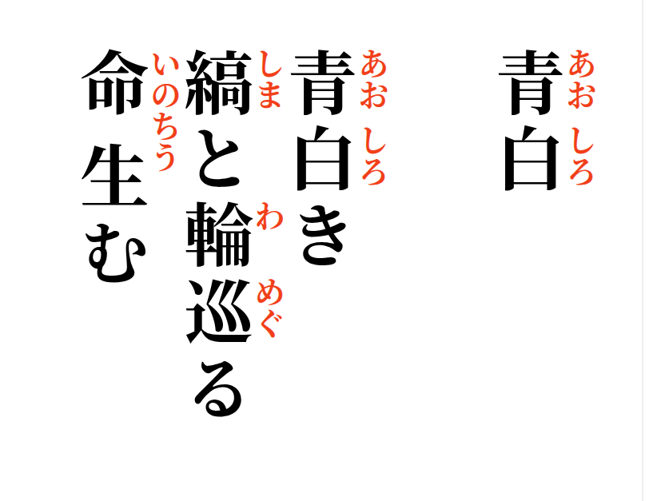
2026-09-19


Blue and White
Blue and white—
stripes and circles turning,
life is born

